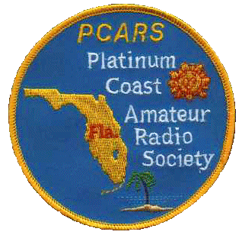
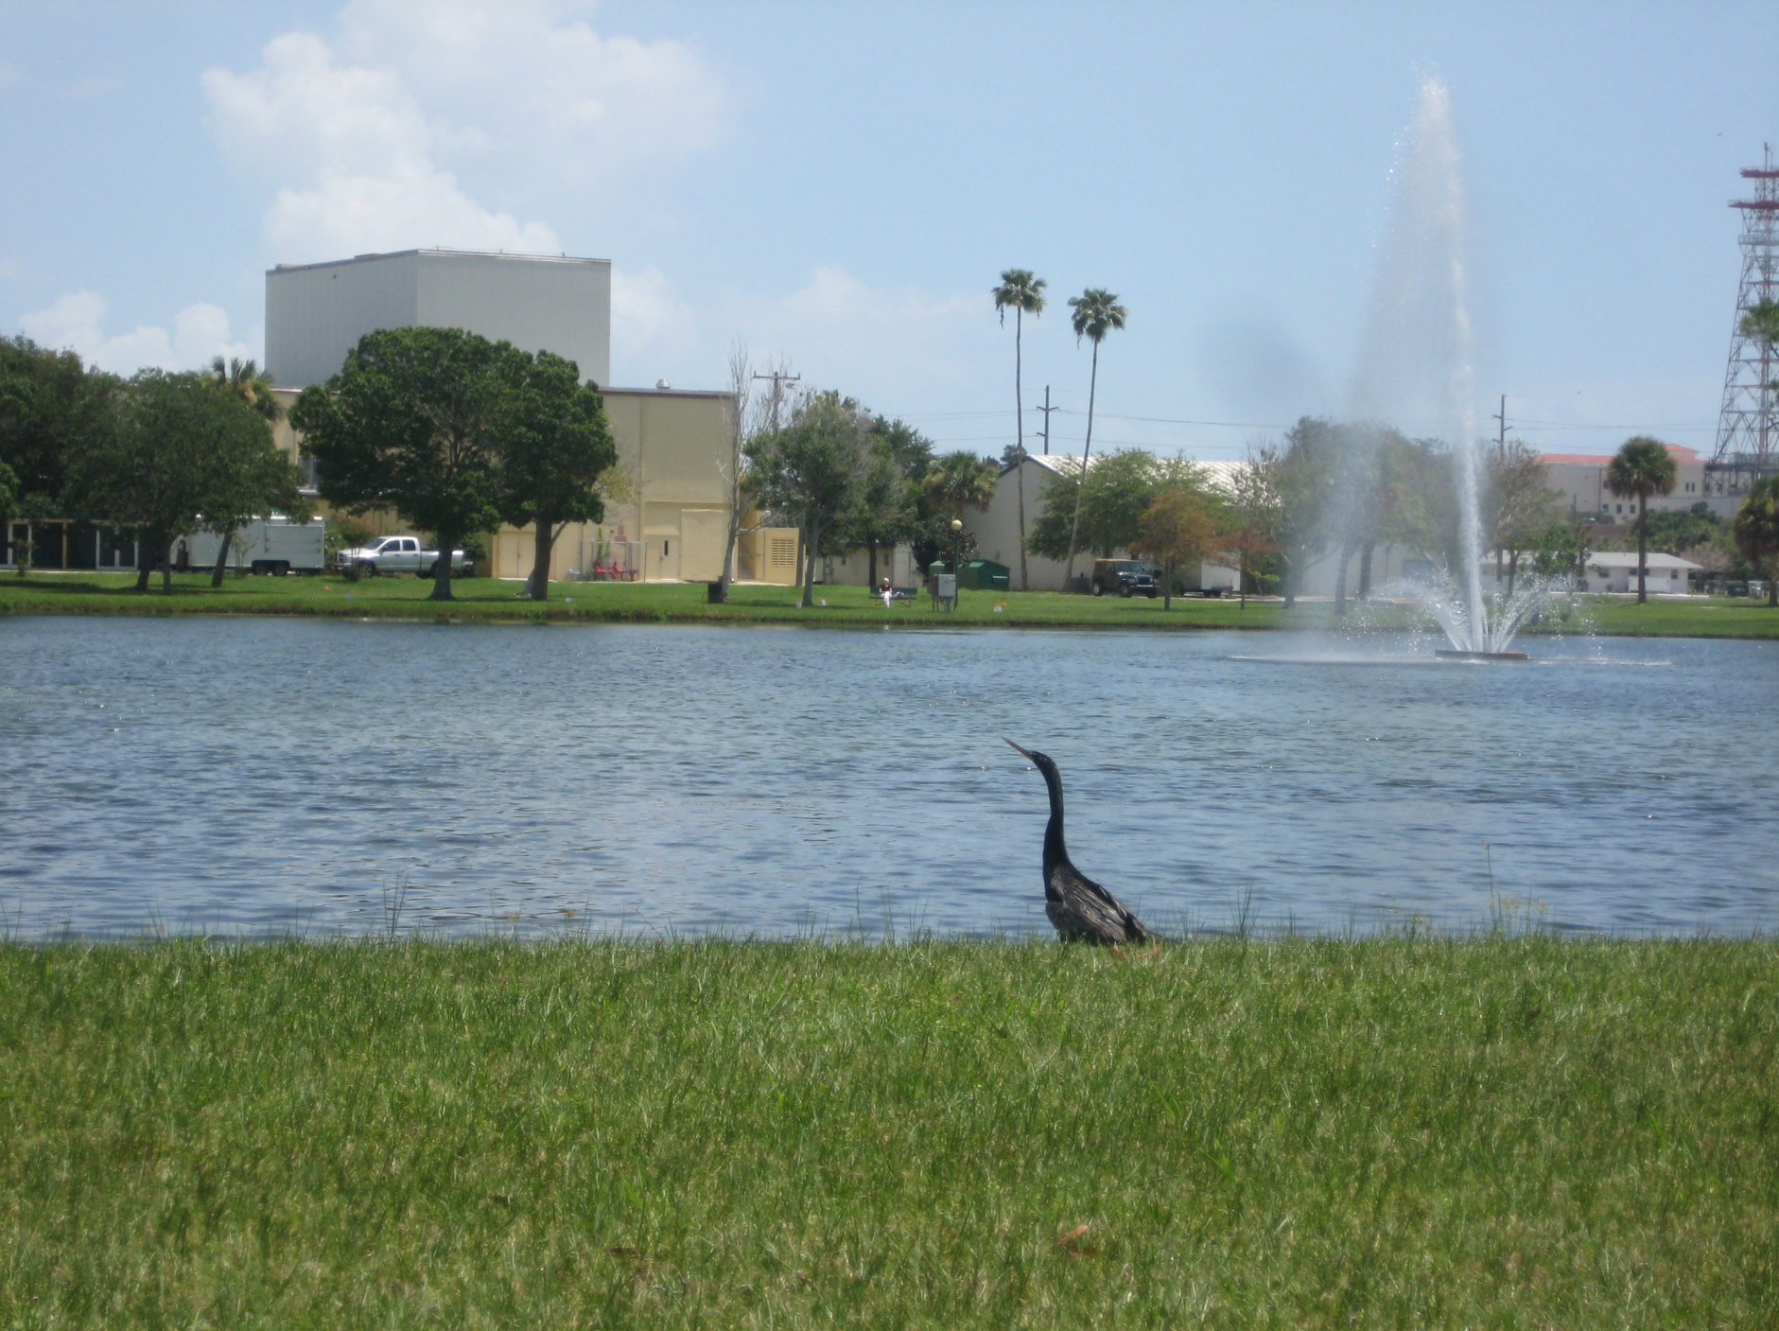

Platinum Coast Amateur Radio Society (PCARS)
Cordially Invites You, Your Friends and Your Family to Our

47th Melbourne Hamfest&
2012 ARRL State Convention
October 13 & 14, 2012

Photo by AK4R

Saturday: 9AM-5PM Sunday: 9AM-2PM

Location: Melbourne Auditorium

625 East Hibiscus Boulevard

Melbourne, Florida 32901
(next to beautiful Wells Park)
Setup: Friday October 12th 6:00PM to 9:00PM
Saturday October 13th 7:00AM to 9:00AM
Talk in: W4MLB,146.25/146.85 repeater
(No PL, Open Repeater)
Contact: John Lundberg, W2TX
Address: 4140 Rosewood Avenue, Malabar, Florida 32950
Phone: 321-723-7582
Email: hamfest2012@pcars.org

Lots of Activities, Events, Features:

Tailgating: Great outside area: $10.00 per designated parking space
First come, first served after 4:00PM Friday. The areas not designated regular parking are $2.00/linear foot and are only assigned by special request.
Come early - open at 6:00AM on Saturday! Hamfest tickets are required in the tailgate area.

Trading: Large indoor swap area. Order form on next-to-last page.

SellUrStuff: Consignment table run by PCARS
Bring us your equipment…we sell it for you!
Easy, trouble free, modest fee.
Vendors: Many commercial vendors will be attending.
Commercial booths are still available
Prizes: This year’s main prizes are:
Yaesu FT-857D with YSK-857 Separation Kit!
Yaesu FT-7900R with YSK-7800 Separation Kit!
Yaesu FT-270R!
LMR-600; 100 ft. with connectors!
Also, multiple dual-band handheld radios will be given away in the hourly drawings!
A BIG THANK YOU to Yaesu, ARRL, and HRO-Atlanta for contributing to this year’s hamfest prizes. Also a big THANK YOU to TMS for donating the LMR-600 cable!
Technical: Many first rate technical talks & forums, DX, AMSAT, youth area, program & special guests…something for everyone
Exams: Amateur Radio Exams will be given on site… get that higher class license and more privileges now! Contact: Judy; aa9gw@juno.com
ARES: Amateur Radio Emergency Service (ARES) Badging available all day Saturday. Contact: Ray; rkassis@cfl.rr.com
Awards: ARRL Awards checking available Saturday
Internet: Free Wireless Internet on site
Website: www.pcars.org see this site for additional info:
Vendor booth, swap table, tailgate area layouts,
local hotel information and program details

Technical Talks

Weak Signal Operation on VHF, UHF and Microwaves. (10 AM, Sat; Catterton Hall)
Chuck Hoover K0VXM, Merritt Island, FL.

EMCOMM and EOC’s - Working with Government Agencies (11:15 AM, Sat; Catterton Hall)
Captain Stephen Szabo WB4OMM, Port Orange, FL.
Daytona Beach PD/EOC Director (Retired): Steve was assigned as the Daytona Beach EOC Director for over 10 years and served from the Wildfires of 1998 to the Floods of 2009.
Steve will provide a short presentation on how EOCs and various government organizations work and how Amateur Radio and EmComm can mutually benefit each other.

Renewable Energy Resources (12:30 PM, Sat; Catterton Hall)
Thomas Morris KG4CYX, Miami, FL.
Renewable energy is a safe, non-polluting method of powering your radio equipment and even your entire home, either on or off the grid. Learn about using wind, solar, hydroelectric, and other safe, reliable energy sources to capture energy, store, and convert it for use.

Heathkit at its Best (1:45PM, Sat; Catterton Hall)
Bud Simciak W4HXP, Melbourne, FL.
History of a gone by era. Stories of how Heathkit product development worked and what working for Heath was all about by one of the project engineers that worked there.

FCC Examinations
9:30AM-Noon, Sat and Sun, Good Hall
Judy Gardner, AA9GW Melbourne, FL

You will need to bring a photocopy of 2 ID’s; 1 needs to be a photo ID/driver’s license and/or passport, and a photocopy of your radio license, if you have one. If you are upgrading, you will also need a photocopy of your CSCE. The fee is $15; due to past problems with checks, cash only, please.
Arrive no later than 11:00 am.

Forums, Meetings, Activities
Quarter Century Wireless Association (QWCA) (9-10AM, Sat; MR#1)
Jeff Beals, WA4AW: Were you first licensed prior to 1987? Are you a member of QCWA - the Quarter Century Wireless Association? If not, you should be! Come to the forum and learn what QCWA is all about. If you are presently a QCWA member, please come and find out what is going on in your organization.

American Radio Relay League (ARRL) Division and Section (10-11AM, Sat; MR#1)
David Fowler, K4DLF West Palm Beach, FL & Jeff Beals, WA4AW Huntsville, AL
David and Jeff will review ARRL Division and Section activities, and be available for a question and answer
session.

American Radio Relay League (ARRL) National Office (1-2 PM, Sat; Good Hall)
Chuck Skolaut, K0BOG Newington, CT : Chuck will make a presentation on the Official Observer Program, Good Operating Practices, and the Intruder Watch Program.

Contesting (11-1PM, Sat; MR#1)
Dan Street, K1TO, of Myakka City, FL: This forum will include Contesting Do’s and Don’ts by the Experts, Automated Antenna Switching by K5KG, and an WRTC 2014 Update. Come and meet contesters from around the state!

ARES/RACES
Ray Kassis, N4LEM: ARES Badging will be available Saturday in the auditorium.

DX (1-2PM, Sat; MR#1)
Sherri Brower, W4STB: 'The ABCs of DXing.' This program designed for those new to DXing and those DXers who have been QRT for a while.

MARS Forum (2-3 PM, Sat; MR#1)
Ron Jakubowski, K2RJ: Military Auxiliary Radio System (MARS) Army, Navy/Marine Corps, and Air Force Branches provide contingency radio communications support to U.S. Government operations and civil agencies. Come find out about its mission and history, and meet with active members and State and Regional officials.

Youth Forum (2-4PM, Sat; Good Hall)
Dan Fisher, AI4GK Palm Bay, FL
JACK THE RADIO DOG will be here to teach kids about basic electronics and they will build their own radio using SNAP CIRCUIT KITS. These activities are approved for kids age 5 and up!

Florida Repeater Council (3-5PM, Sat; MR#1)
Marshall Paisner, N4BIF: The meeting starts off by opening up the floor to interested parties that have issues or questions pertaining to amateur repeater systems in Florida. The second half of the meeting is a Board Session where the FRC Staff and Directors work through the various items on our agenda.

DXCC Card Checking (Sat; Table #100)
Ned Buck, W4KS Melbourne, FL

Registration Information: Tickets purchased before Sept. 30 are $6.00, and $7.00 after Sept. 30, 2012. Tickets are required everywhere on auditorium property-inside and outside. Aged 12 and under are FREE. Requests must include Self Addressed Stamped Envelope for advance tickets or pick-up at the door.

NAME/Company/Callsign___________________________________________________________________

STREET ____________________________________________________________PH___________________

CITY________________________________STATE____ZIP________Email___________________________

Swap Tables, $20.00 Each Table # Request __________ QTY._____ $___________

Entry and prize tickets (and setup passes) @ $6.00 each QTY._____ $___________

Make Checks Payable to PCARS Melbourne Hamfest TOTAL $___________

Commercial booths – Contact us for size and location availability.

See more info and latest updates on our PCARS web site: www.pcars.org Go to the PCARS HAMFEST link

E-Mail your information requests to hamfest2012@pcars.org

Hamfest Chair: John Lundberg (W2TX) Home phone: 321-723-7582
FREE Wireless Internet on site

Mail: PCARS Melbourne Hamfest
P.O. Box 1004
Melbourne, FL 32902-1004

Map

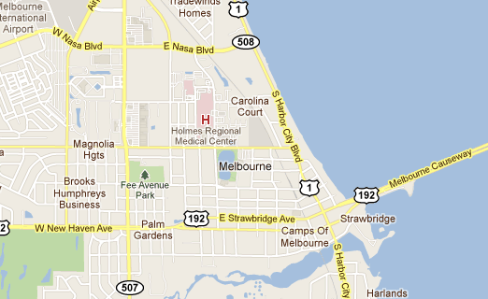
E. Hibiscus Blvd.
Hamfest

