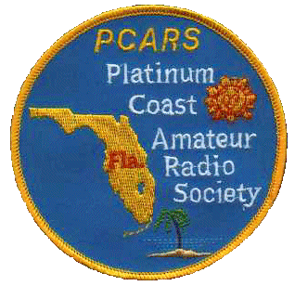
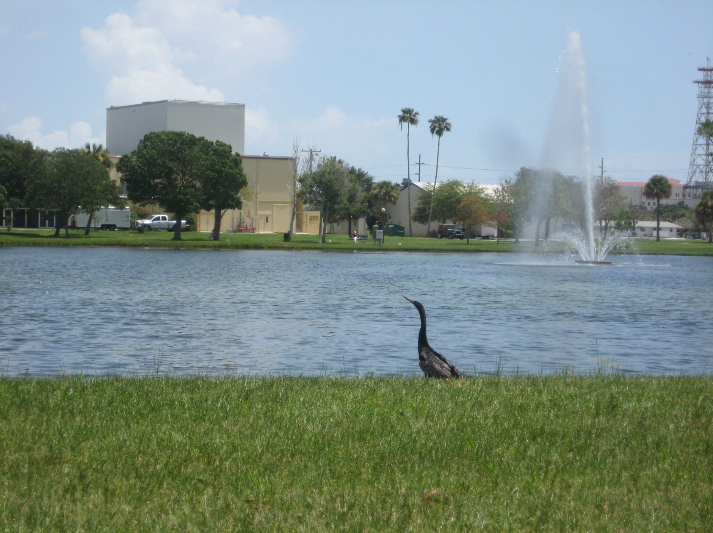

Platinum Coast Amateur Radio Society (PCARS)
Cordially Invites You, Your Friends and Your Family to Our

47th Melbourne Hamfest&
2012 ARRL State Convention
October 13 & 14, 2012

Photo by AK4R

Saturday: 9AM-5PM Sunday: 9AM-2PM

Location: Melbourne Auditorium

625 East Hibiscus Boulevard

Melbourne, Florida 32901
(next to beautiful Wells Park)
Setup: Friday October 12th 6:00PM to 9:00PM
Saturday October 13th 7:00AM to 9:00AM
Talk in: W4MLB,146.25/146.85 repeater
(No PL, Open Repeater)
Contact: John Lundberg, W2TX
Address: 4140 Rosewood Avenue, Malabar, Florida 32950
Phone: 321-723-7582
Email: hamfest2012@pcars.org

Lots of Activities, Events, Features:

Tailgating: Great outside area: $10.00 per designated parking space
First come, first served after 4:00PM Friday. Areas not designated regular parking are $2.00/linear foot and only assigned by special request.
Come early - open at 6:00AM on Saturday! Hamfest tickets are required in the tailgate area.

Trading: Large indoor swap area. Order form on last page.

SellUrStuff: Consignment table run by PCARS
Bring us your equipment…we sell it for you!
Easy, trouble free, modest fee.
Vendors: Many commercial vendors will be attending.
Commercial booths are still available
Prizes: Great main prizes…and other prizes as well!
A BIG THANK YOU to: Bird Technologies, ICOM, ARRL, and HRO-Atlanta for contributing to last year’s hamfest prizes. Also a big THANK YOU to TMS for the first donation of a prize to this year’s hamfest-100 ft. of LMR-600 with connectors!
Technical: Many first rate technical talks & forums..DX, AMSAT, youth area, program & special guests…something for everyone
Exams: Amateur Radio Exams will be given on site… get that higher class license and more privileges now! Contact: Judy, aa9gw@cfl.rr.com
ARES: Amateur Radio Emergency Service (ARES) Badging available all day Saturday. Contact: Ray; rkassis@cfl.rr.com
Awards: ARRL Awards checking available Saturday
Internet: Free Wireless Internet on site
Website: www.pcars.org see this site for additional info on
Vendor booths, swap tables, tailgate area layouts,
local hotel information and program details

Technical Talks

Renewable Energy Resources
Thomas Morris KG4CYX, Miami, FL

Weak Sig Ops above 30 MHz
Charles A. Hoover K0VXM, Merritt Island, FL

Forums, Meetings, Activities
Quarter Century Wireless Association (QWCA) (9-10AM, Sat; MR#1)
Ken Simpson, W8EK: Were you first licensed prior to 1987? Are you a member of QCWA - the Quarter Century Wireless Association? If not, you should be! Come to the forum and learn what QCWA is all about. If you are presently a QCWA member, please come and find out what is going on in your organization. A national director (Ken, W8EK) will be present to answer your questions.

Federal Communications Commission (FCC) Examinations (9:30AM-1PM, Sat and Sun)
Judy Gardner, AA9GW Melbourne, FL

American Radio Relay League (ARRL) Division and Section (10-11AM, Sat; MR#1)
David Fowler, K4DLF West Palm Beach, FL & Greg Sarratt, W4OZK Huntsville, AL
David and Greg will review ARRL Division and Section activities, and be available for a question and answer session.

Contesting (11-1PM, Sat; MR#1)
Dan Street, K1TO, of Myakka City, FL:

ARES/RACES (1-2 PM, Sat; MR#2, Auditorium Stage)
Ray Kassis, N4LEM: Ray will answer questions and concerns as well as describe the roll that Amateur Ham Radio Operators play in Disasters and Emergencies through ARES and BEARS for the County and the Red Cross. ARES Badging will also be available Saturday.

DX (1-2PM, Sat; MR#1)

MARS Forum (2-3 PM, Sat; MR#1)
Ron Jakubowski, K2RJ: Military Auxiliary Radio System (MARS) Army, Navy/Marine Corps, and Air Force Branches provide contingency radio communications support to U.S. Government operations and civil agencies. Come find out about its mission and history, and meet with active members and State and Regional officials.

Youth Forum (2-4PM, Sat; MR#2 - stage)
Aaron Mitchell, KJ4DDM Melbourne, FL & Dan Fisher, AI4GK Palm Bay, FL
JACK THE RADIO DOG will be here to teach kids about basic electronics and they will build their own radio using SNAP CIRCUIT KITS. These activities are approved for kids age 5 and up!

Florida Repeater Council (3-5PM, Sat; MR#1)
Marshall Paisner, N4BIF: The meeting starts off by opening up the floor to interested parties that have issues or questions pertaining to amateur repeater systems in Florida. The second half of the meeting is a Board Session where the FRC Staff and Directors work through the various items on our agenda.

DXCC Card Checking (Sat; Table #100)
Ned Buck, W4KS Melbourne, FL

Registration Information: Tickets purchased before Sept. 30 are $6.00, and $7.00 after Sept. 30, 2011. Tickets are required everywhere on auditorium property-inside and outside. Age 12 and under are FREE. Requests must include Self Addressed Stamped Envelope for advance tickets or pick-up at the door.

NAME/Company/Callsign___________________________________________________________________

STREET ____________________________________________________________PH___________________

CITY________________________________STATE____ZIP________Email___________________________

Swap Tables, $20.00 Each Table # Request __________ QTY._____ $___________

Entry and prize tickets (and setup passes) @ $6.00 each QTY._____ $___________

Make Checks Payable to PCARS Melbourne Hamfest TOTAL $___________

Commercial booths – Contact us for size and location availability.

See more info and latest updates on our PCARS web site: www.pcars.org Go to the PCARS HAMFEST link

E-Mail your information requests to hamfest2012@pcars.org

Hamfest Chair: John Lundberg (W2TX) Home phone: 321-723-7582
FREE Wireless Internet on site

Mail: PCARS Melbourne Hamfest
P.O. Box 1004
Melbourne, FL 32902-1004

Map

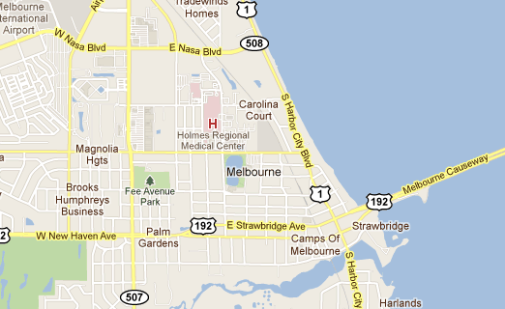
E. Hibiscus Blvd.
Hamfest

