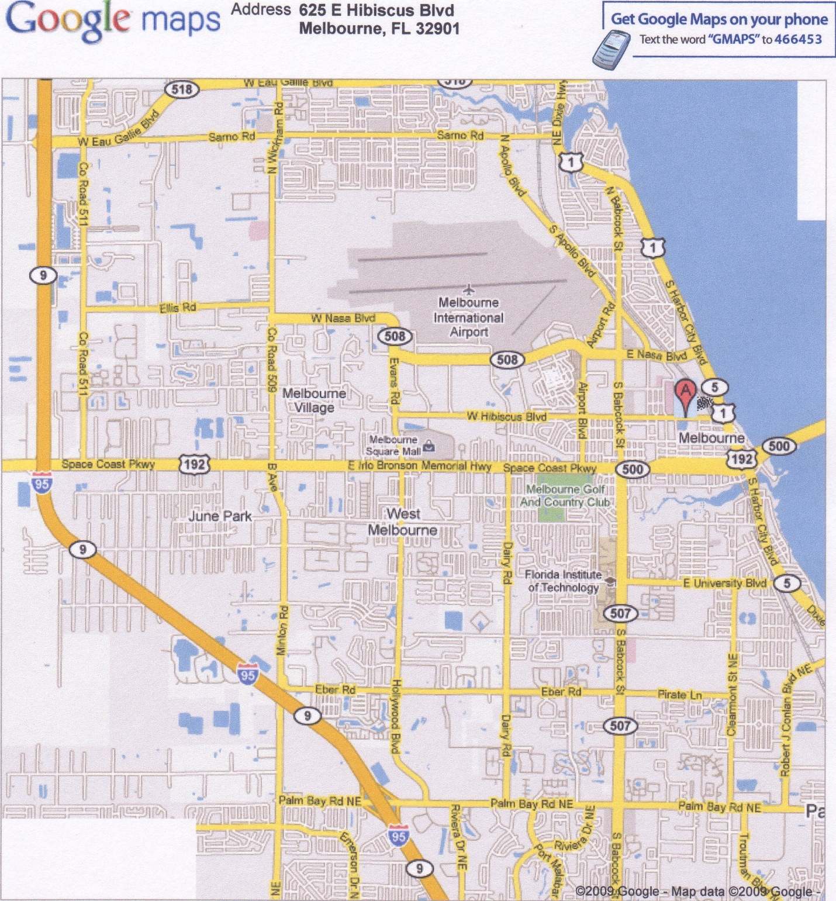

192

Exit #180

W

E

Palm Bay Road

Exit #173

Eau Gallie Blvd

Exit #183

S

N

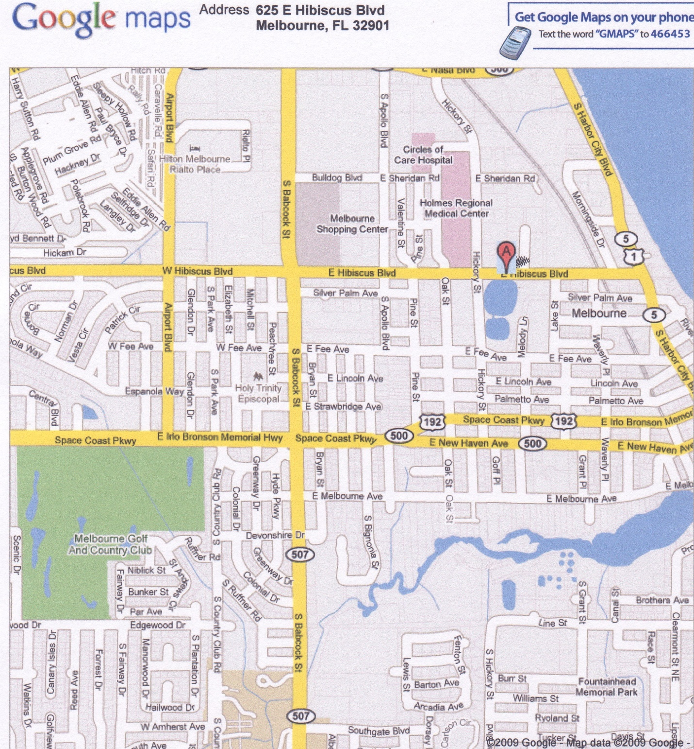

W

S

N

E