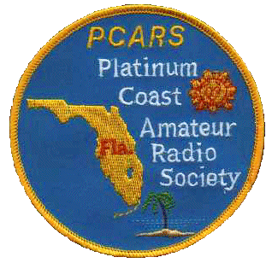
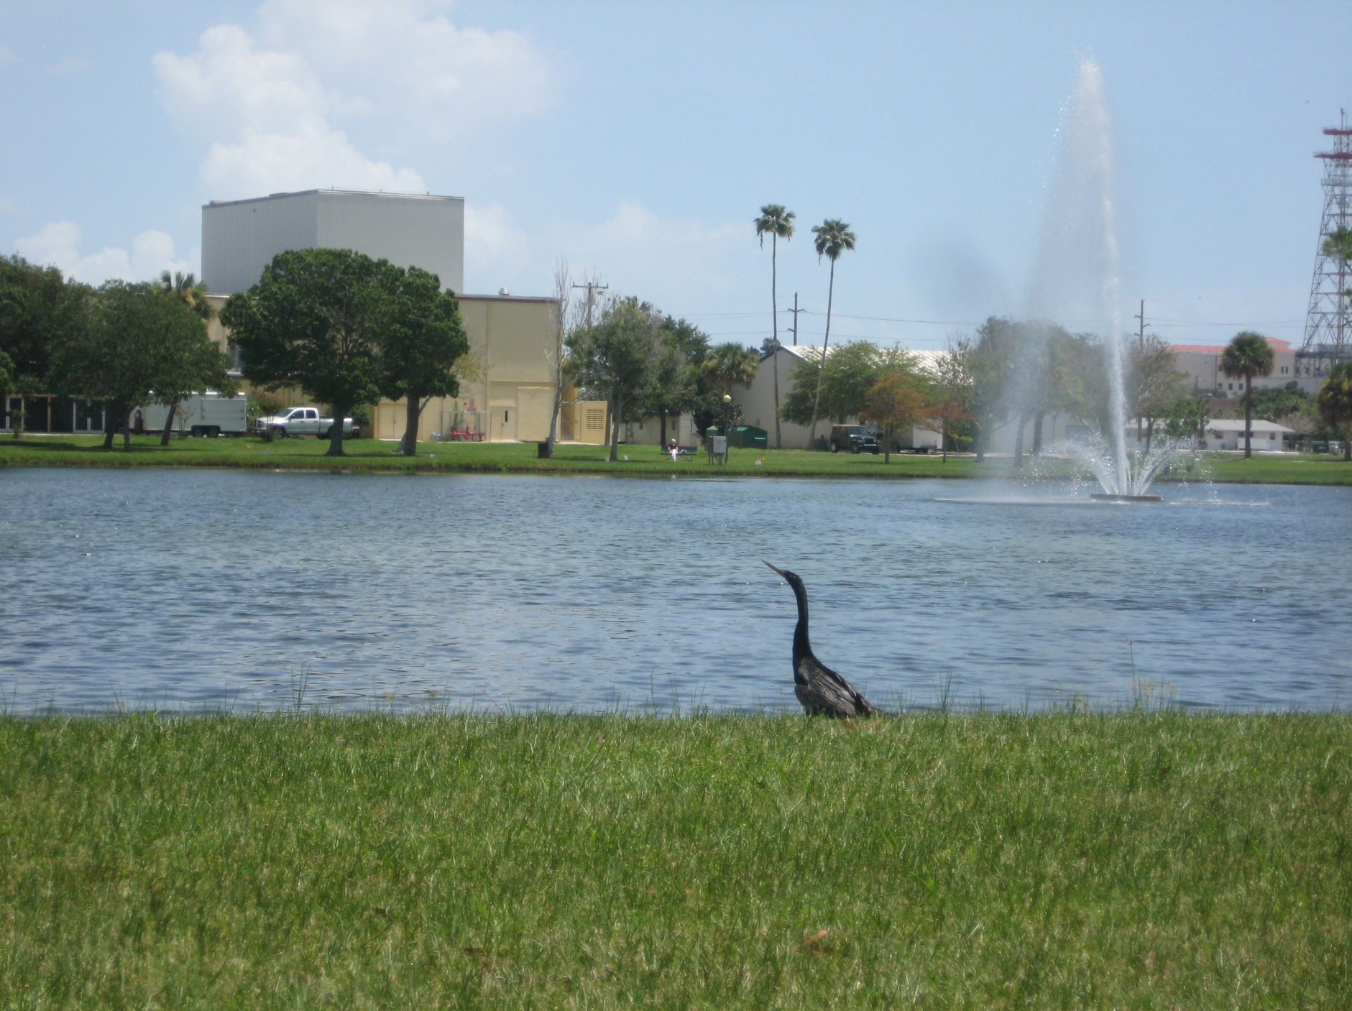

Platinum Coast Amateur Radio Society (PCARS)
Cordially Invites You, Your Friends and Your Family to Our

48th Melbourne Hamfest &
2013 ARRL State Convention
October 12 & 13, 2013

Photo by AK4R

Saturday: 9AM-5PM Sunday: 9AM-2PM

Location: Melbourne Auditorium

625 E. Hibiscus Boulevard, Melbourne, FL 32901
(Next to beautiful Wells Park)
Admission: Tickets are $6.00 before Sept. 30 and $7.00 after Sept. 30, 2013.
Talk in: W4MLB,146.25/146.85 repeater
(No PL, Open Repeater)
Chairman: Don Winn, AF4Z; 321-254-9495
Booths/Tables: Kathy Quinn, KI4RQY; 321-327-2647
Email: hamfest2013@pcars.org
Mail: PCARS Melbourne Hamfest
P.O. Box 1004
Melbourne, FL 32902-1004

Lots of Activities, Events, Features:

Indoor Setup: Commercial Booths and vendors with 10 or more tables: Noon to 7 PM.
Others: 3:00 to 7:00 PM
Tailgating: Great outside area: $10.00 per designated parking space
First come, first served after NOON Friday. The areas not designated regular parking are $2.00/linear foot and are only assigned by special request.
Come early - open at 6:00AM on Saturday! Hamfest tickets are required in the tailgate area.

Trading: Large indoor swap area. Order form on next-to-last page.

SellUrStuff: Consignment table run by PCARS
Bring us your equipment…we will sell it for you!
Easy, trouble free, modest fee.
Vendors: Many commercial vendors will be attending.
Commercial booths are still available
Prizes: This year we already have prizes donated by:
Balun Designs Ten-Tec
Bird Technologies CQ Magazine
MFJ NCG/Comet
Tigertronics West Mountain Radio
ARRL DX Engineering
Times Microwave HRO-Atlanta
Kenwood
Technical: Many first rate technical talks & forums, DX, AMSAT, youth area, program & special guests…something for everyone
Exams: Amateur Radio Exams will be given on site… get that higher class license and more privileges now! Contact: Judy; aa9gw@juno.com
ARES: Amateur Radio Emergency Service (ARES) Badging available all day Saturday. Contact: Ray; rkassis@cfl.rr.com
Website: www.pcars.org see this site for additional info:
Vendor booth, swap table, tailgate area layouts,
local hotel information and program details

Technical Talks
Julia Irvin, WJ1A Melbourne, FL

A 10 GHZ Beacon (10-11AM, Sat; Good Hall)
Chuck Hoover K0VXM, Merritt Island, FL. The FLWSS 10 GHz beacon built and installed in the outer banks of North Carolina.

EMCOMM and EOC’s (1-2PM, Sat; Good Hall)
Stephen Szabo, WB4OMM, Port Orange, FL.

Staying on the Air but Under the Radar – Living with Antenna Restrictions (2-3PM, Sat; Good Hall)
Tim Cotton N4UM, Vero Beach, FL

FCC Examinations
9:30AM-Noon, Saturday
Judy Gardner, AA9GW Melbourne, FL

You will need to bring a photocopy of 2 ID’s; 1 needs to be a photo ID/driver’s license and/or passport, and a photocopy of your radio license, if you have one. If you are upgrading, you will also need a photocopy of your CSCE. The fee is $15; due to past problems with checks, cash only, please.
Arrive no later than 11:00 am.

Forums, Meetings, Activities
Quarter Century Wireless Association (QWCA) (9-10AM, Sat; MR#1)
Jeff Beals, WA4AW Huntsville, AL: Were you first licensed prior to 1987? Are you a member of QCWA - the Quarter Century Wireless Association? If not, you should be! Come to the forum and learn what QCWA is all about. If you are presently a QCWA member, please come and find out what is going on in your organization.

American Radio Relay League (ARRL) Division and Section (10-11AM, Sat; MR#1)
Section: David Fowler, K4DLF West Palm Beach, FL & Jeff Beals, WA4AW Huntsville, AL
Division: Gregg Sarrat, W4OZK Huntsville, AL & James Millsap, WB4NWS Acworth, GA
This meeting will review ARRL Division and Section activities, and will include a question and answer session.

American Radio Relay League (ARRL) National Office (11:30-12:30, Sat; Good Hall)
Dan Henderson, N1ND Newington, CT

The Florida Contest Group (11AM-1:00PM, Sat; MR#1)
Dan Street, K1TO, of Myakka City, FL, will speak on WRTC 2014
Eric Smitt, K9ES, and Chuck Green, AD4ES, Melbourne, FL, will speak on the WRTC Practice Event held this July.
There will also be a roundtable discussion featuring 5 local contesters; K1XX, N4BP, AD4Z, W4UH, and K1TO.

MARS Forum (2-3PM, Sat; MR#1)
Ron Jakubowski, K2RJ: Military Auxiliary Radio System (MARS) Army, Navy/Marine Corps, and Air Force Branches provide contingency radio communications support to U.S. Government operations and civil agencies. Come find out about its mission and history, and meet with active members and State and Regional officials.

Florida Repeater Council (3-5PM, Sat; MR#1)
Marshall Paisner, N4BIF: The meeting starts off by opening up the floor to interested parties that have issues or questions pertaining to amateur repeater systems in Florida. The second half of the meeting is a Board Session where the FRC Staff and Directors work through the various items on our agenda.

Awards Checking (All day Saturday; Auditorium)
Ned Buck, W4KS
QSL card checking for DXCC, WAS, WAC and VUCC awards.

ARES/RACES Badging (All day Saturday; Auditorium)
Ray Kassis, N4LEM

Registration Information: Tickets purchased before Sept. 30 are $6.00, and $7.00 after Sept. 30, 2013. Tickets are required everywhere on auditorium property-inside and outside. Aged 12 and under are FREE. Requests must include Self Addressed Stamped Envelope for advance tickets or pick-up at the door.

NAME/Company/Callsign___________________________________________________________________

STREET ____________________________________________________________PH___________________

CITY________________________________STATE____ZIP________Email___________________________

Swap Tables, $20.00 Each Table # Request __________ QTY._____ $___________

Entry and prize tickets (and setup passes) @ $6.00 each QTY._____ $___________

Make Checks Payable to PCARS Melbourne Hamfest TOTAL $___________

Commercial booths – Contact us for size and location availability.

See more info and latest updates on our PCARS web site: www.pcars.org Go to the PCARS HAMFEST link

E-Mail your information requests to hamfest2013@pcars.org

Booths/Tables: Kathy Quinn (KI4RQY) Home phone: 321-327-2647

Mail: PCARS Melbourne Hamfest
P.O. Box 1004
Melbourne, FL 32902-1004

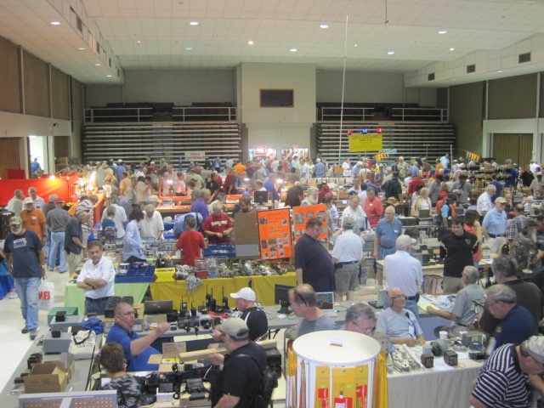

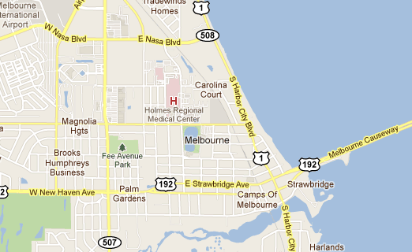
Hamfest
E. Hibiscus Blvd.

